PCF OpenShift Migration – Onboarding Document

1/23/2023 – V0.2

Table of Contents
1. Okta MFA Set up 1
1.1 PRE-REQUISITES 1
1.2 STEPS 2
2. Security Questions Set Up 4
3. Raising Request For Software’s 5
3.1 Via ESI App Portal 5
3.2 Via Request Tickets 6
4. APPENDIX 7
Section 1 7
Section 2 7
Section 3 8
Section 4 8
Section 5 9
Section 6 9
Section 8 11
Section 9 12

- Okta MFA Set up

1.1 PRE-REQUISITES
- ESI LAN ID
- PASSWORD
- If you are a new hire, please use the temporary password that your manager has provided you. (You will be prompted to change to a permanent password before moving forward). Click Verify.

1.2 STEPS

- From your browser, go to https://cigna.okta.com/ and follow the instructions listed below.
- Your Username is your Domain\LANID. Click Next.
Examples of
Domain\LANID:
Health Services Username: ACCOUNTS\A12345
- Type in your LAN password (same as Cigna password). If you are a new hire, please use the temporary password that your manager has provided you. (You will be prompted to change to a permanent password before moving forward). Click Verify.
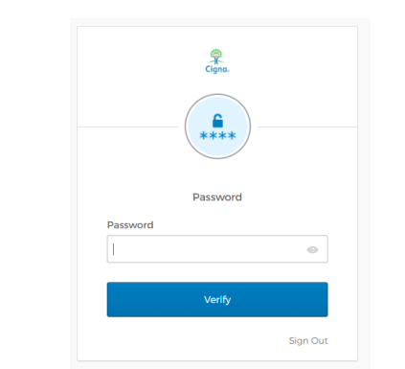
- Under your name in the upper right hand corner, click Settings.
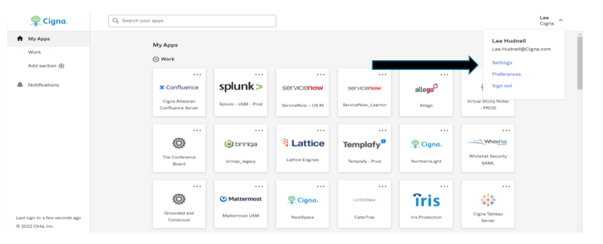
- Click on the Edit Profile button (1) in upper right of the screen. Once you input credentials (if needed), scroll down and you will see Extra Verification. Click Set up on the factor you would like to use:

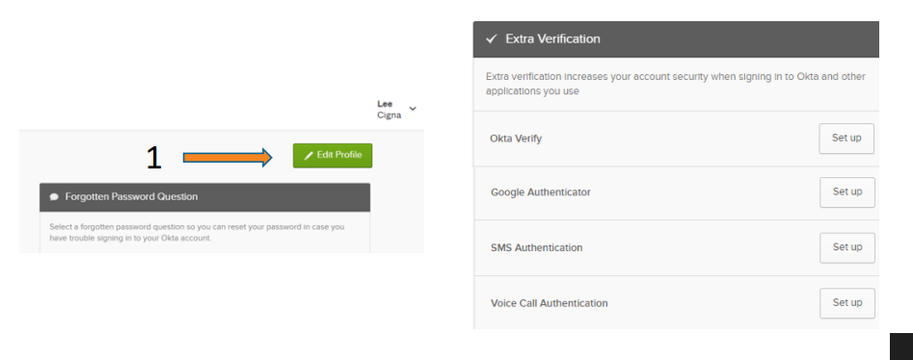
- Click on Set Up for Okta Verify
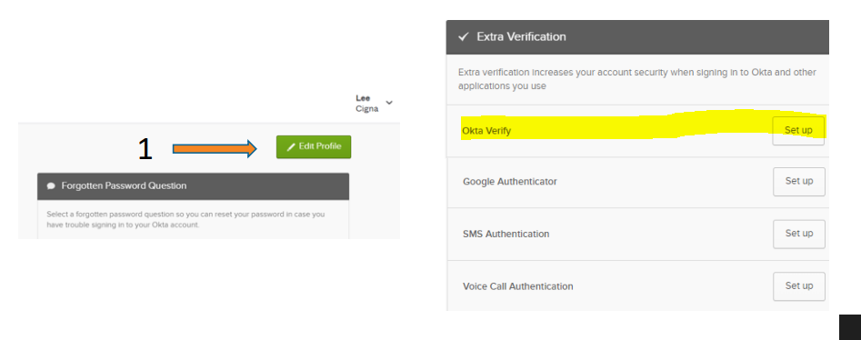
- Okta Verify Steps:
  - You will see a Set up prompt for Okta Verify. Click Setup
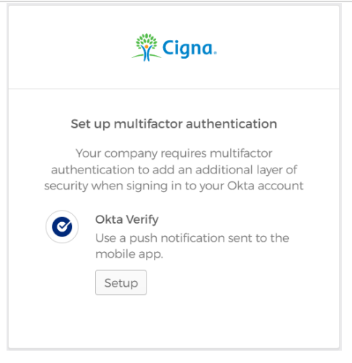
  - You will be asked to set up your device type. Select either iPhone or Android and Click Next
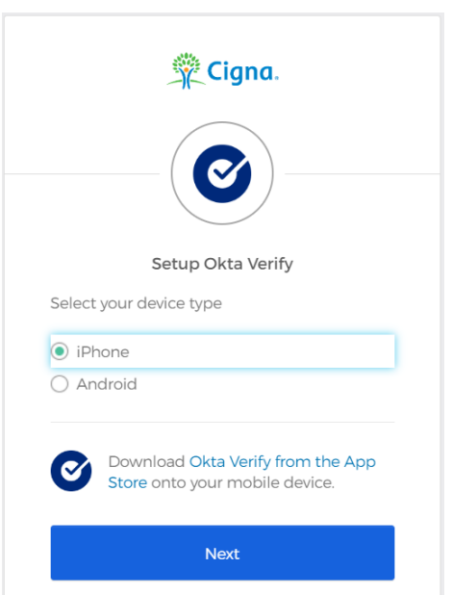
  - Go to your mobile device’s store and download the Okta Verify app. Then launch the app, select “Add an Account”. Scan the QR Code to continue
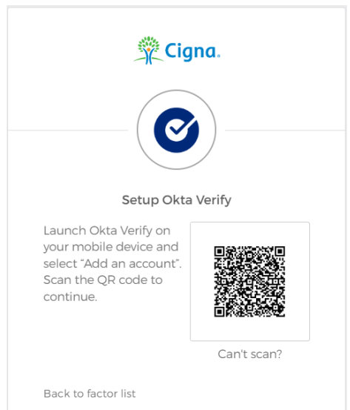
  - You are now enrolled in Okta Verify!

- Security Questions Set Up

- Visit https://cigna.service-now.com/esp
- Click on you name at top right corner and click on “Manage Security Settings”

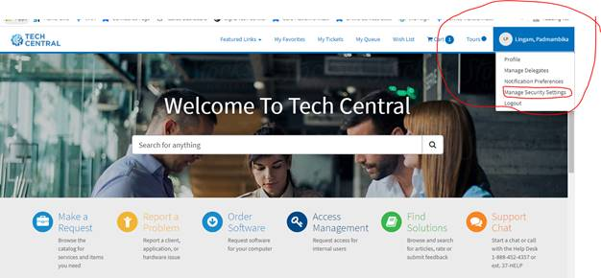

- Fill in all the security questions and answers (Ensure to remember the answers)
- Click on submit.

- Raising Request For Software’s

3.1 Via ESI App Portal
Go to the mentioned link to install the following software listed below.
Step-1:- Go to esiappportal for installing the required software http://esiappportal/ESD/Home

Step-2:- Go to the search bar and search mentioned software from the list below.
- Robo3T
- IntelliJ
- Node Js
- Git
- Soap Ui
- Postman
- Winmerge
- NotePad++
- JDK 1.8
- WebEx Messaging
Step-3:- After choosing the software click on the cart symbol on the top right hand corner of the page. Then submit and checkout.
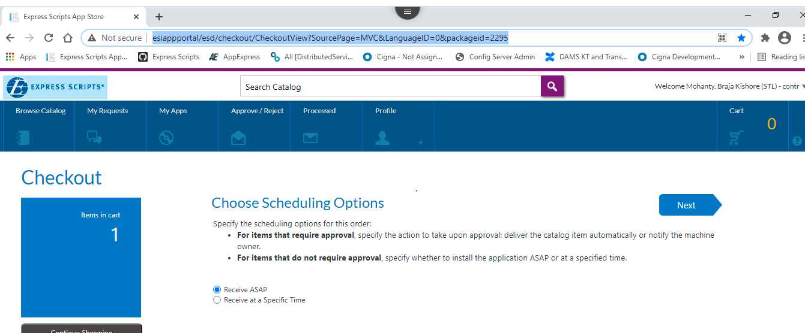

3.2 Via Request Tickets
- Go to requesting for the access for below list in user and group access form.
New Relic | Refer to section 1 of Appendix
App express | Default Access will be there, check else raise request
Jenkins | Refer to section 2 of Appendix
Confluence | Refer to section 3 of Appendix
Hermes | Default Access will be there, check else raise request
Quay | Default Access will be there, check else raise request
Egress Connectivity Helper | Default Access will be there, check else raise request
ArgoCD | Specific to namespace, can invoke access as needed.
ESI GITHUB | Refer to section 4 of Appendix
Cigna GITHUB | Refer to section 5 of Appendix
Splunk | Refer to section 6 of Appendix
Openshift Access | Refer to section 7 of Appendix

- APPENDIX

Section 1
New Relic Access:-
- Open Tech central
- Make a Request (Follow below screenshot to fill details and submit request)
- In search bar write users & Groups Access Request
- Select group name APP_NewRelic_NONPROD, APP_NewRelic_PROD
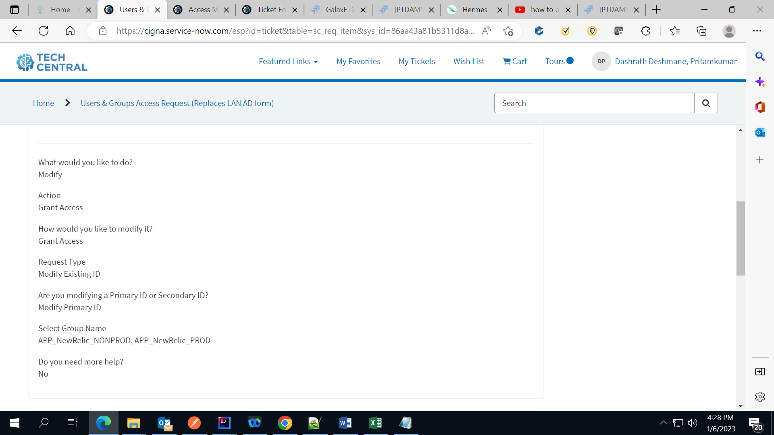
- After the request is granted, try to access https://rpm.newrelic.com with your credentials.
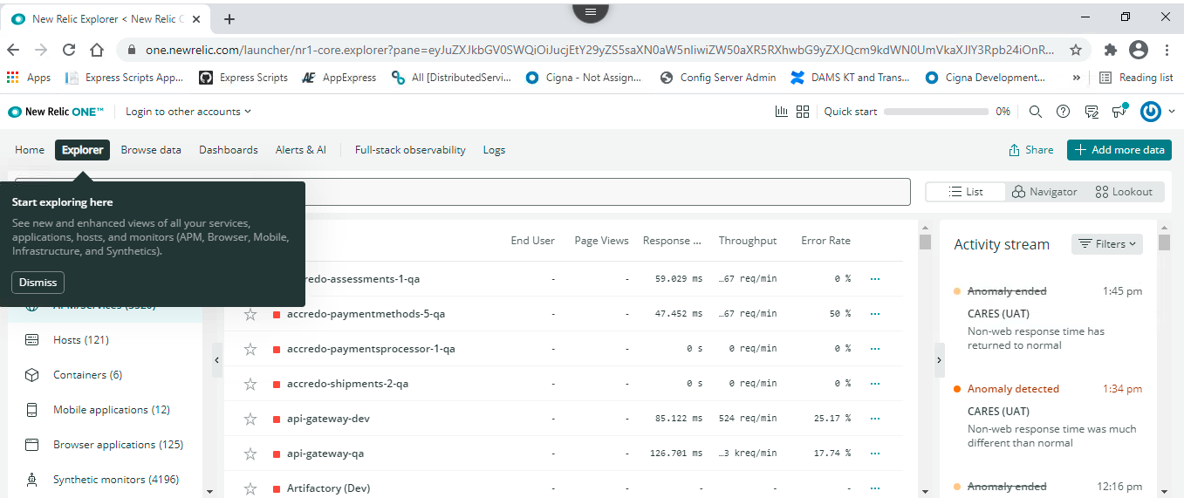

Section 2
Jenkins Access:-
- Open Tech central
- Make a Request (Follow below screenshot to fill details and submit request)
- In search bar write “Jenkins Enterprise – Request”
- Follow below screenshot and submit request
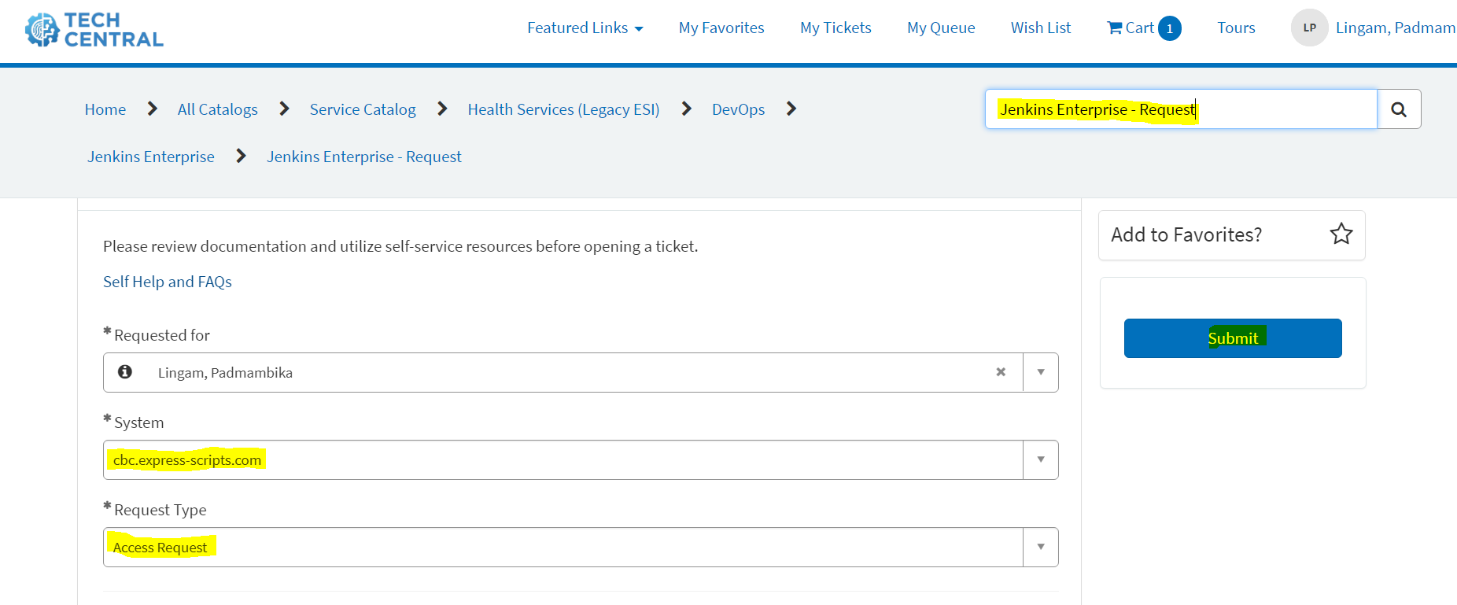

Section 3
Confluence Access:-
1. Access https://cigna.service-now.com/esp?id=sc_cat_item&sys_id=7c6e71dddb4ab890092cc458139619ab
2.Populate the form
3. Requested for: Choose your name
4. Which Confluence environment is this for?: confluence.sys.cigna.com
5. Type of request: General question
6. Space URL: https://confluence.sys.cigna.com/display/k8s/OpenShift++Container+Management+Platform+Home
7. Additional Information: HS resource requiring access
8. Submit the form

Section 4
ESI GITHUB Access:
- Open Tech central
- Make a Request (Follow below screenshot to fill details and submit request)
- In search bar write “GitHub / GitLab - Request”
- Follow below screenshot and submit request
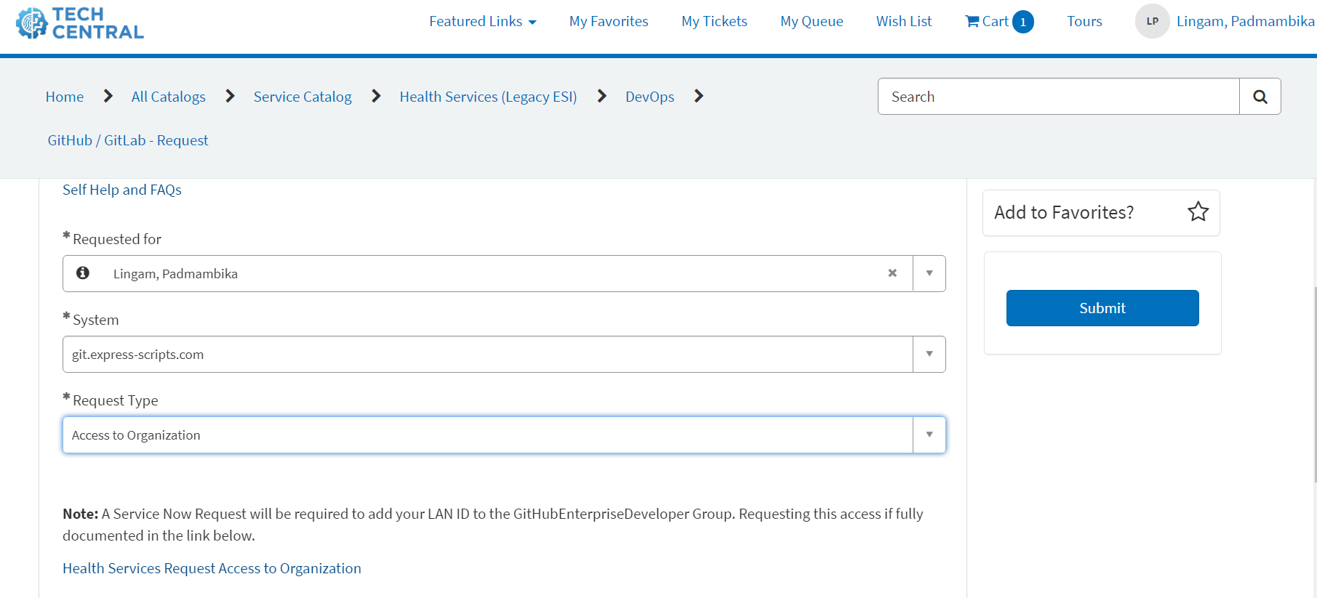

Section 5
CIGNA GITHUB Access:
- Open Tech central
- Make a Request (Follow below screenshot to fill details and submit request)
- In search bar write “GitHub / GitLab - Request”
- Follow below screenshot and submit request
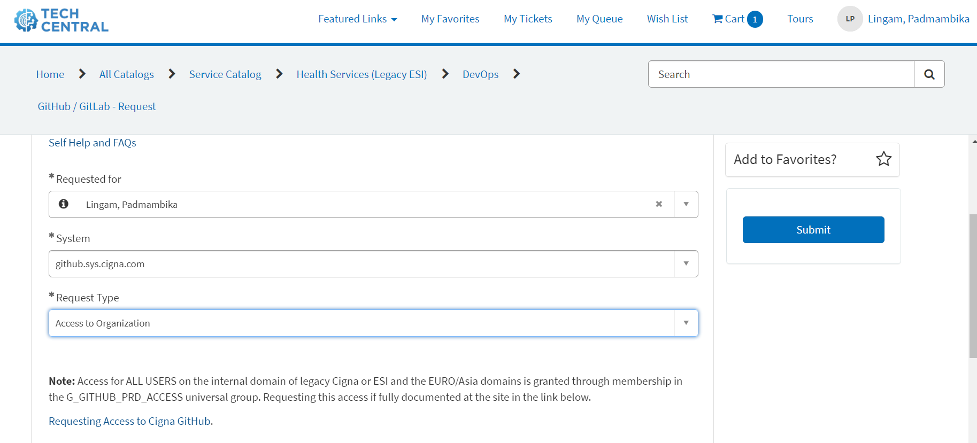

Section 6
Splunk Access:
- Open Tech central
- Make a Request (Follow below screenshot to fill details and submit request)
- In search bar write users & Groups Access Request
- Follow below screenshot and submit request

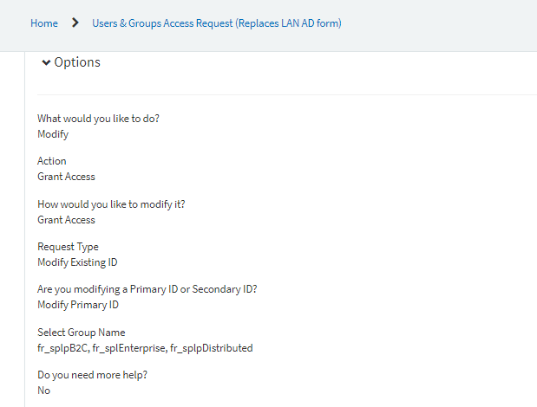

Section 7
Openshift Access:
- Navigate to https://accessmanagement.sys.cigna.com/.
- Choose "Manage Access"
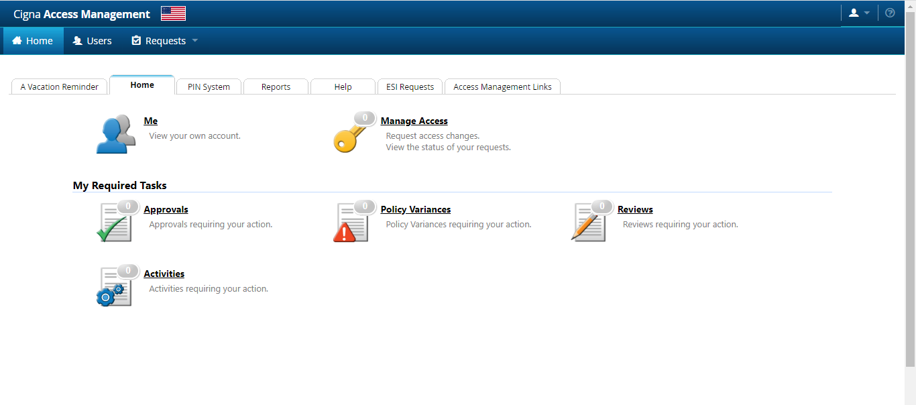
- Under "Company Systems", select "Request Access to Shared / Global Group".
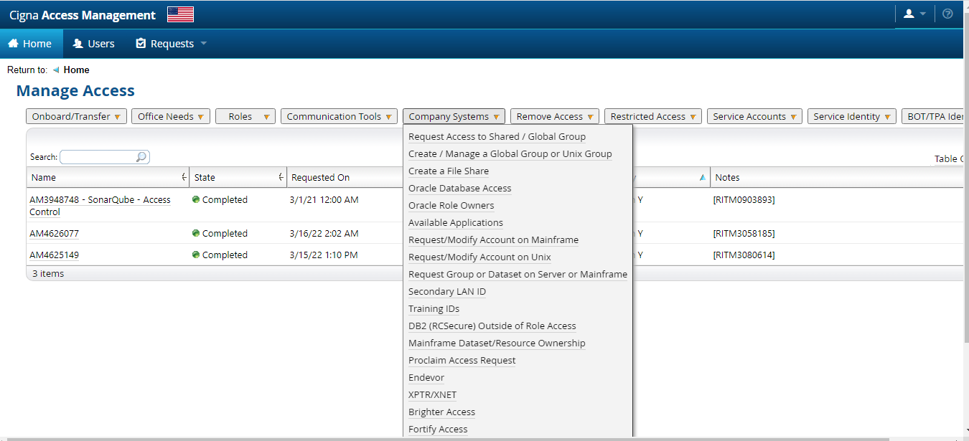
- Check the box to the left of your user.
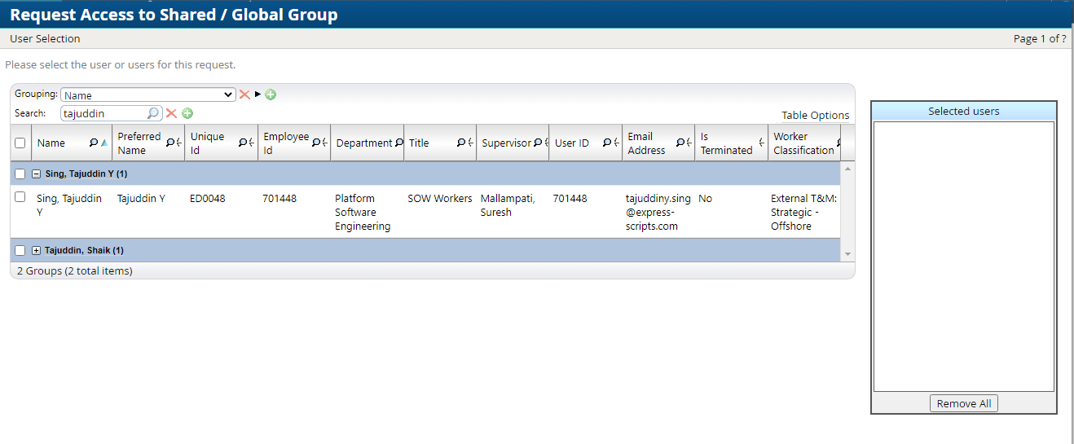
- Click the "Next" button at the bottom of the page.
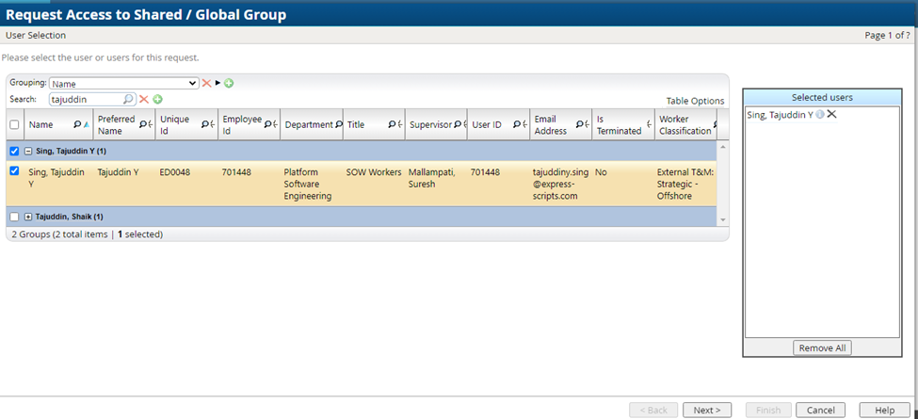
- Select "INTERNAL" as the Domain
- Enter the group name (Example: G_CPC_USER) to search for and then click the magnifying glass icon. NOTE: groups that you already have will not appear in the search results.
- Check the "Add" button to the left of the desired group.
- Repeat steps 7 and 8 for all groups that you need which are: G_CPC_USER, G_OPENSHIFT_PRD
- Click the "Next" button at the bottom of the page.
- Enter a description of the request.
- Click the "Finish" button at the bottom of the page.

Section 8
IntelliJ set up:
- Go to Tech Central
- Click on Order Software (in Microsoft edge as Chrome has problem)
- Search for IntelliJ in the catalogue
- Click on Add to cart
- Download & Install from - http://esiappportal/esd/
License information - Getting IntelliJ and WebStorm License
FAQ - IntelliJ FAQs
IntelliJ set up with ZScaler
- JDK specific for ESI usage
Download & Install from - http://esiappportal/esd/ (Java JDK 1.8 Manual Install)
Adding CA Certs - Adding ESI CA Cert(s) to Java Install
- Start IntelliJ in evaluation mode
Select ‘Evaluate for free’ radio button and click ‘Evaluate’ and then click ‘Close’
Go to File → settings → Appearance and Behavior → System settings → HTTP proxy
Select ‘Auto detect proxy’ → click ‘Check Connection’ → enter the URL https://jetbrains.express-scripts.com → click ‘OK’ → There will an error message – Can be ignored → click ‘Ok’ on the error window. Click ‘OK’ on the settings window → go to ‘Help’ → Register → click ‘Add New License’ → select ‘License Server’ → Enter the above URL → Click ‘Test Connection’ → Activate

Section 9
JIRA Access:-
Raise a request for accessing Jira:
JIRA Generic Access | https://jira.express-scripts.com/servicedesk/customer/portal/5/create/46
JIRA Elevated Access | https://jira.express-scripts.com/servicedesk/customer/portal/5/create/48

